Chapter 1: Introduction

Overview
The healthcare industry is currently witnessing a massive digital transformation. With the rapid advancement of technology, traditional healthcare systems are becoming obsolete, failing to meet the growing demands of patients for speed, efficiency, and accessibility. Smart Healthcare Systems—powered by Artificial Intelligence (AI) and Cloud Computing—are no longer a luxury but a necessity. This project proposes a comprehensive, smart healthcare ecosystem designed to bridge the gap between patients and medical service providers, ensuring a seamless, data-driven experience for all stakeholders.

Problem statement:
- "What problem do people have that we are here to fix?"
The traditional healthcare sector suffers from several critical challenges that negatively impact both patient experience and medical efficiency. These challenges can be summarized as follows:

- Wasted time: Long and tedious waiting periods in clinics due to poor appointment scheduling.

- Dispersion of medical data: The lack of a unified medical record for the patient (medical history, medications, X-rays) leads to difficulty in accurate diagnosis when changing doctors.
- Difficulty in immediate access: The lack of rapid initial medical guidance (triage) in emergency or minor cases, which unnecessarily increases the pressure on hospitals.

- Fragmented Services: The patient makes an appointment with the doctor, then goes to the pharmacy, then to the lab... a tiring and disjointed journey.

Project Objectives:

Main Goal
The primary goal of this project is to develop a Smart Healthcare Ecosystem that integrates patients, doctors, and pharmacists into a single, unified platform. This platform aims to facilitate access to healthcare services, digitize medical records, and utilize AI for preliminary diagnosis assistance.

Specific Objectives
  - Minimize Waiting Time: By implementing a smart booking algorithm that organizes appointments efficiently.

  - Digital Transformation: Creating a unified Electronic Medical Record (EMR) for each patient, accessible securely by authorized doctors.

  - AI-Powered Assistance: Deploying an AI Chatbot capable of performing preliminary triage, analyzing symptoms, and recommending the appropriate medical specialty.

  - Service Integration: Closing the healthcare loop by connecting doctor prescriptions directly to e-pharmacy services for home delivery.

Project Scope:

This project focuses on the software development of a Smart Healthcare Web Platform. The scope boundaries are defined as follows:

In-Scope:

  - Web Application: A comprehensive web-based platform serving three main actors: Patients, Doctors, and Administrators.

  - AI Module: Developing a Natural Language Processing (NLP) model to act as a smart medical assistant for symptom checking and specialty recommendation.

  - Online Payment Integration: Integrating a secure third-party payment gateway (e.g., Stripe or Pay mob) to allow patients to pay for consultations and medications online.

  - Core Features:
    - Smart appointment booking and scheduling.
    - AI Chatbot for triage services.
    - E-Prescription management and pharmacy routing.
    - Electronic Medical Records (EMR) management.

Out-of-Scope:

- Mobile Application: The current phase focuses exclusively on the Web Platform; a mobile application is planned for future phases.

- Hardware Integration: The integration of physical IoT devices or medical sensors is not part of this thesis scope but is considered for future scalability.

- Emergency Trauma Handling: The system is designed for outpatient care and non-critical cases. Life-threatening emergencies are redirected to SOS services.
- Banking Core Development: While online payment is supported, the project relies on external payment processors and does not involve building a native financial banking system.

Thesis Organization:
The remainder of this report is organized as follows:
- Chapter 2 (Literature Review): Reviews existing healthcare systems (such as Vezeeta), analyzes their limitations, and discusses the technologies used in this project (MERN Stack, Python).

- Chapter 3 (System Analysis): Details the functional and non-functional requirements, use case diagrams, and system specifications.

- Chapter 4 (System Design): Presents the system architecture, database design (ERD), and user interface designs.

- Chapter 5 (Implementation & Testing): Discusses the development process, code structure, and testing scenarios.

- Chapter 6 (Conclusion): Summarizes the project outcomes and suggests future enhancements.

Chapter 2: Literature Review & Background

introduction:
The healthcare industry is currently witnessing a paradigm shift from traditional, reactive care to proactive, data-driven digital health ecosystems. This transformation, often referred to as "HealthTech," integrates technologies such as Artificial Intelligence (AI), Cloud Computing, and Mobile Health (mHealth) to improve patient outcomes. Recent studies indicate that the main challenges in modern healthcare are not just about the availability of doctors, but the accessibility of data and the efficiency of the triage process. While traditional systems focus on "sick care" (treating patients after they become ill), modern Smart Healthcare systems aim to provide continuous care, early diagnosis assistance via AI, and a unified view of the patient's medical history. This project aligns with this global trend by proposing an integrated ecosystem that bridges the gap between logistical efficiency (booking) and clinical intelligence (AI diagnosis).

Existing Systems & Related Work:
To identify the current market gap, several existing solutions were analyzed. The selection includes Vezeeta (Regional Leader), Practo (Global Competitor), and Babylon Health (AI-Focused Solution).

Vezeeta (MENA Region Market Leader)
- Description: Founded in Egypt, Vezeeta is the leading digital healthcare platform in the Middle East and North Africa. It primarily functions as a booking marketplace connecting patients with doctors and pharmacies.
- Pros/Features:
  - Extensive Network: Huge database of doctors with verified patient reviews.
  - User Experience: Intuitive interface for searching and booking appointments.
  - E-Pharmacy: Recently integrated medicine ordering services.
- Cons/Limitations:
  - Lack of AI Triage: The platform relies entirely on the patient knowing which specialty they need. There is no intelligent guidance for symptoms.
  - Fragmented Records: It does not offer a unified Electronic Medical Record (EMR) that aggregates history, labs, and radiology in a standardized format accessible across different clinics.
  - Commercial Focus: The primary focus is logistical (filling appointment slots) rather than clinical (patient health tracking).

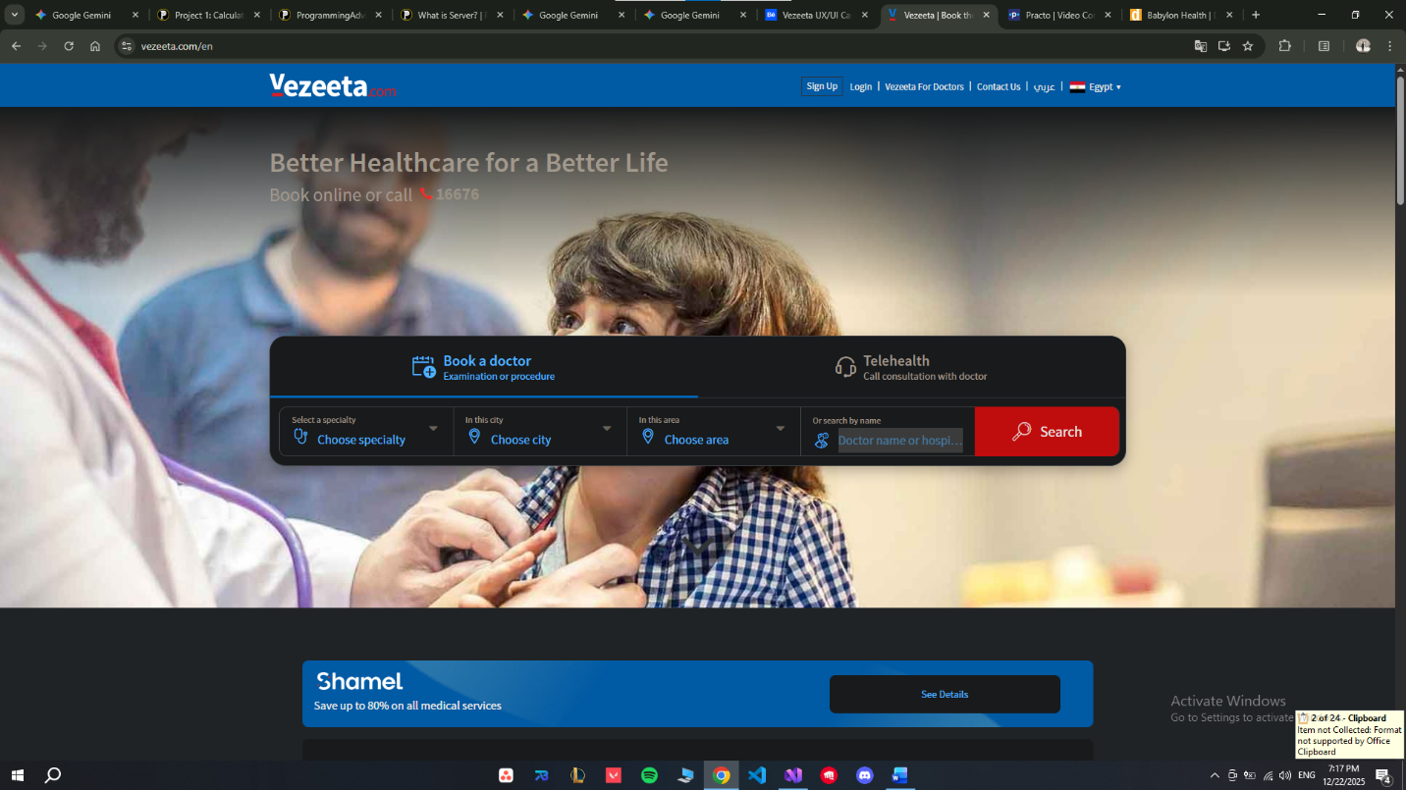
Figure 1: Vezeeta.com Home Page Interface showcasing the search FUNCTIONALITY.

Practo (Global Competitor - India/Asia)
- Description: Practo is one of the world's largest integrated healthcare platforms. It offers booking, online consultations, and health record storage.
- Pros/Features:
  - Telemedicine: Robust video consultation infrastructure.
  - Practo Ray: A practice management software for doctors to manage clinics.
  - Health Articles: Rich content regarding health awareness.
- Cons/Limitations:
  - Complex UI: The interface is often cluttered with ads and upselling, making it difficult for elderly users to navigate.
  - Limited AI Personalization: While it stores records, it does not actively use AI to analyze this data for predictive health insights or personalized warnings.

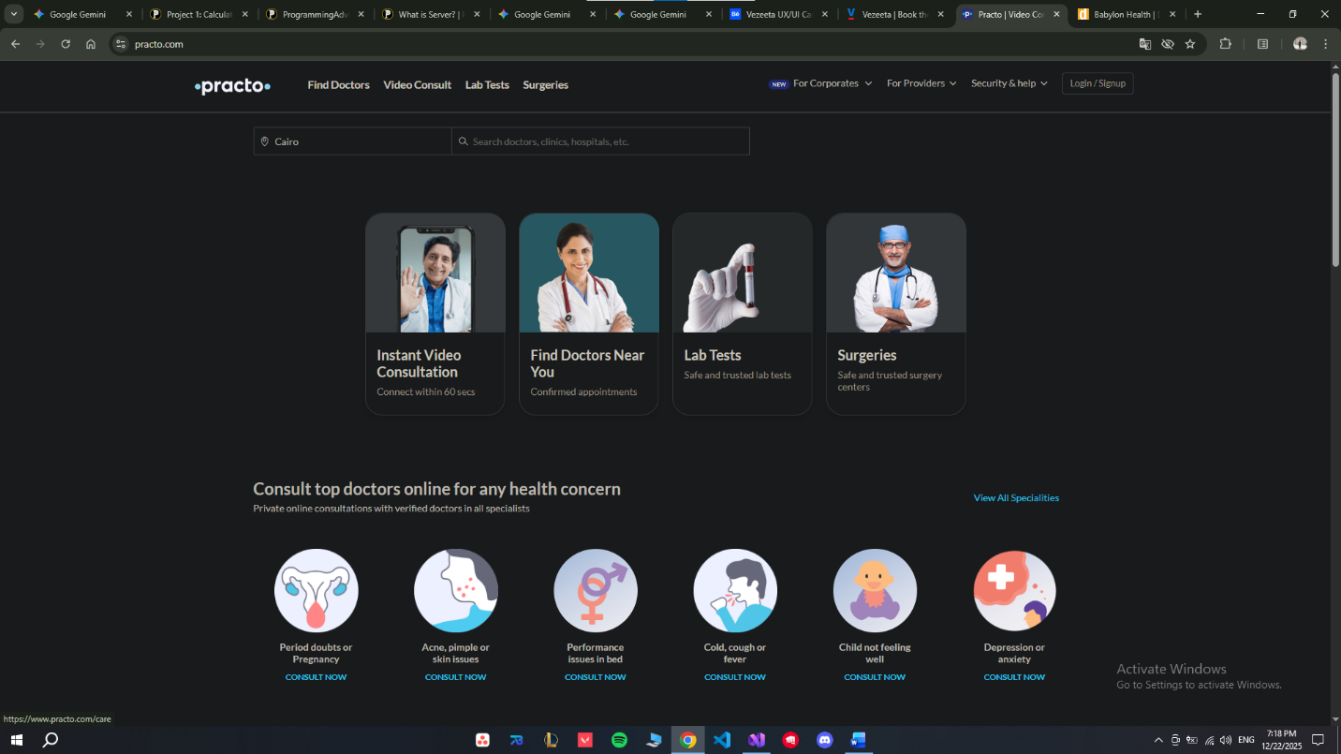
Figure 2 Practo Landing Page displaying various healthcare services.

Babylon Health (AI-Driven Competitor - UK)
- Description: A UK-based digital-first health service provider that became famous for its AI-powered "Symptom Checker."
- Pros/Features:
  - Advanced AI: Uses a probabilistic graphical model to interpret symptoms with high accuracy.
  - Triage Capability: Effectively directs patients to the right level of care (self-care, GP, or emergency).
- Cons/Limitations:
  - Subscription Model: Operates mostly on a paid subscription basis, limiting accessibility for public use in developing markets.
  - Limited Physical Network: Focuses heavily on virtual care, lacking the extensive "on-ground" doctor network for physical visits compared to booking platforms like Vezeeta.

Comparative Analysis:

Table 2.1 summarizes the key differences between the proposed Smart Healthcare Ecosystem and the analyzed existing systems.
1Feature Comparison TABLE:
feature | Our system | vezeeta | practo | Babylon health
Core function: | Integrated Ecosystem (AI + Booking + EMR) | Booking & Marketplace | Booking & Telehealth | AI Symptom Checker
AI-Based triage | Available (NLP) | Not Available | Limited | Advanced
Unified EMR  (Medical History) | Centralized & Shared | Local/Fragmented | Available | Available
Family Management | One Dashboard | Separate Accounts | Partial | Available
Pharmacy Integration | Auto-Routing (Prescription based) | Manual Ordering | Manual Ordering | Limited
User Interface Complexity | Low (Simple for elderly) | Low | High | Medium
Cost Model | Free | Free | Free | Subscription

Research Gap (ProbleM Statement):
Based on the critical analysis of the existing systems, a clear gap in the current market and research landscape was identified:
  - The "Logistics vs. Intelligence" Gap: Platforms like Vezeeta excel at logistics (booking) but lack clinical intelligence (AI). Conversely, platforms like Babylon excel at AI but lack the extensive on-ground network of doctors in the local region.
- The Data Silo Problem: There is a significant lack of systems that create a "Closed Loop" experience. Currently, a patient uses one app to book, receives a paper prescription, goes physically to a pharmacy, and keeps their X-rays in a plastic bag at home.
Therefore, this project aims to bridge this gap by developing a localized, unified ecosystem that combines the logistical power of booking engines with the clinical intelligence of AI triage, ensuring a seamless flow of data from the initial symptom check to the final medication delivery.

Theoretical Background:
This section provides a theoretical overview of the key technologies selected to implement the proposed solution.

MERN Stack (Web Development)
The system architecture is built upon the MERN stack, a powerful JavaScript-based framework.
- React.js (Frontend): A library for building user interfaces based on components. It allows for the creation of a Single Page Application (SPA), ensuring a fast and smooth user experience without constant page reloads.
- Node.js & Express (Backend): A runtime environment that allows JavaScript to run on the server. Its non-blocking, event-driven architecture makes it ideal for handling multiple concurrent requests (e.g., hundreds of patients book simultaneously).
- MongoDB (Database): A NoSQL database that stores data in JSON-like documents. It was chosen for its flexibility in handling unstructured medical data (e.g., varying patient history fields).

Artificial Intelligence & NLP
- Natural Language Processing (NLP): A branch of AI that enables computers to understand human language. In this project, NLP is used to power the Chatbot, allowing patients to describe their symptoms in natural language (e.g., "I have a headache") rather than selecting from rigid lists.
- Python: Selected as the backend language for the AI microservice due to its extensive libraries (such as NLTK and Scikit-learn) which are industry standards for developing machine learning models.

Chapter 3: System Analysis & Requirements

Introduction:
This chapter details the analysis and specification of requirements for SAGE (Smart AI-Guided Ecosystem). It outlines the methodology used for development, the data gathering process, and the formal software requirements (Functional and Non-Functional). Furthermore, it presents the system modeling through Unified Modeling Language (UML) diagrams, specifically the Use Case diagram, to visualize the interactions between the users and the system.

Methodology:
To ensure flexibility and continuous improvement, the development of SAGE follows the Agile Scrum Methodology. This approach allows the team to deliver the project in iterative cycles (Sprints), ensuring that feedback from stakeholders is incorporated at every stage.
- Sprints: The project is divided into 2-week sprints, focusing on delivering specific features (e.g., Booking Module, AI Chatbot).
- Collaboration: Regular stand-up meetings are conducted to track progress and resolve blockers efficiently.

Data Gathering:
To identify the real-world problems facing patients in Egypt, a quantitative research method was employed. A digital survey was distributed to a diverse group of participants to gather insights regarding their healthcare experiences.

Survey Analysis
The survey results highlighted several critical "Pain Points" that SAGE aims to resolve:
- Waiting Time: Most respondents indicated that long waiting times at clinics are their primary concern.
- Triage Difficulty: A significant percentage expressed uncertainty about which medical specialty to visit when feeling unwell.
- Adoption of AI: The results showed a high willingness among the youth demographic to use AI tools for preliminary health guidance.

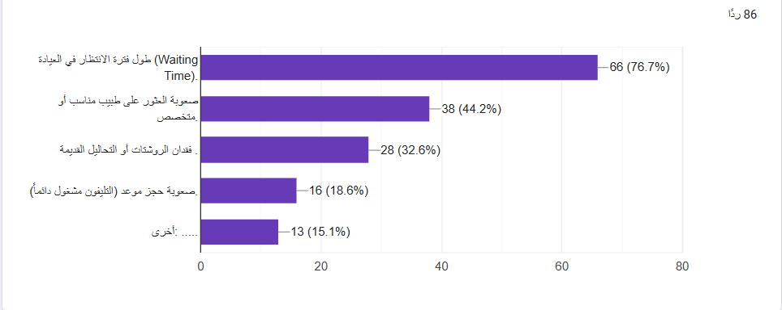
Figure 1 patient problems
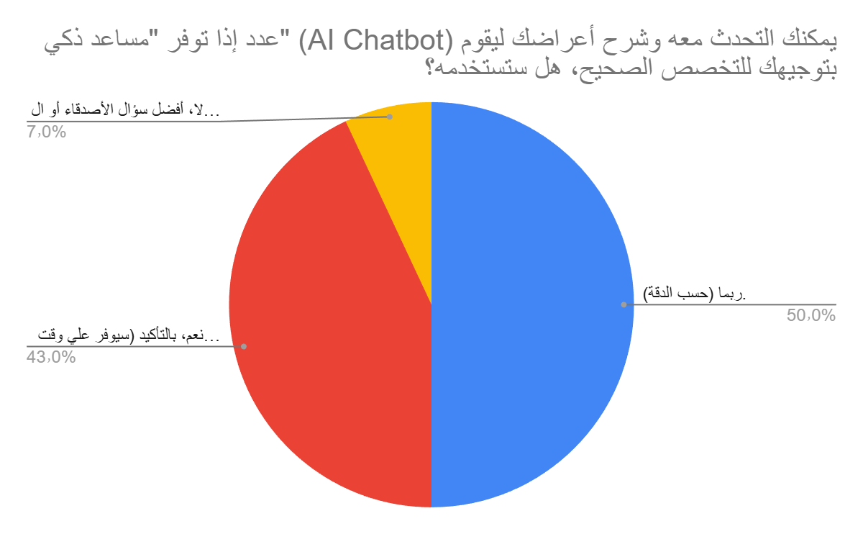

Figure 2 patients willing for ai bot
Figure 3.1: Survey results showing patient pain points and willingness to use AI.

Software Requirements Specification
Based on the analysis, the system requirements are categorized into Functional and Non-Functional requirements.

Functional Requirements (User Stories)
The functional requirements are defined using standard User Stories to describe the system features from the perspective of the end-users (Actors).
A. Patient Module
- REQ-01 (Registration): The system shall allow patients to create secure accounts using their email or phone number.
- REQ-02 (Search & Filter): The system shall allow patients to search for doctors by specialty, location, fees, and rating.
- REQ-03 (AI Triage Chatbot): The system shall provide an NLP-powered chatbot that accepts natural language input (symptoms) and suggests the appropriate medical specialty.
- REQ-04 (Appointment Booking): The system shall enable patients to view doctor availability and book appointments instantly.
- REQ-05 (Medical History): The system shall allow patients to upload and view their medical records (Labs, Prescriptions) on a unified dashboard.
B. Doctor Module
- REQ-06 (Schedule Management): The system shall allow doctors to set their working hours and update slot availability in real-time.
- REQ-07 (Patient Records Access): The system shall grant doctors access to the visiting patient's medical history to aid in diagnosis.
- REQ-08 (E-Prescription): The system shall allow doctors to issue digital prescriptions that are automatically saved to the patient’s profile.
C. Admin Module
- REQ-09 (Doctor Verification): The system shall provide an interface for admins to review and approve doctor documentation before they go live.
- REQ-10 (System Monitoring): The system shall display a dashboard showing platform analytics (Active Users, Total Bookings).

Non-Functional Requirements
These requirements define the quality attributes of SAGE.
- Security: All sensitive patient data (passwords, medical records) must be encrypted using industry-standard protocols (e.g., Bcrypt, AES).
- Performance: The system should respond to user queries (Search, Chatbot) in under 2 seconds to ensure smooth user experience.
- Scalability: The backend architecture must be capable of handling concurrent requests from multiple users without downtime.
- Usability: The User Interface (UI) must be responsive and accessible, designed to be simple enough for elderly patients to navigate.

System Modeling:
To visualize the functional requirements, the Use Case Diagram defines the scope of the system and the interactions between the actors.

Actors Identification
- Patient: The primary user seeking medical care and booking appointments.
- Doctor: The service provider managing schedules and diagnosing patients.
- Admin: The manager responsible for maintaining system integrity and verifying users.

Use Case Diagram
The following diagram illustrates the main interactions within the SAGE ecosystem.
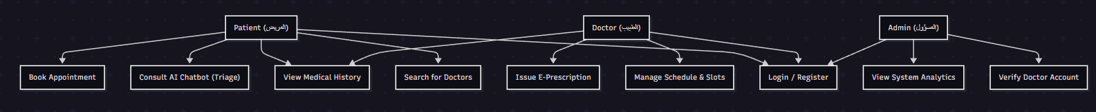

Figure 3.2: Use Case Diagram for SAGE Ecosystem.

Chapter 4: System Design

Introduction:
This chapter presents the architectural and detailed design of SAGE. Following the requirements phase, the system design translates functional needs into a technical roadmap. This includes the high-level system architecture, the database schema (ERD), and the selection of the technology stack to ensure a scalable and secure healthcare ecosystem.

System Architecture:
SAGE utilizes Client-Server Architecture with a microservices-inspired approach for the AI component. This ensures that the heavy processing required for Natural Language Processing (NLP) does not affect the performance of the main booking and management system.
- Frontend Layer: Developed using React.js to provide dynamic and responsive user experience.
- Backend Layer: Built with Node.js and Express, handling the business logic, authentication, and database interactions.
- AI Service: A dedicated Python service that processes patient symptoms using NLP models.
- Database Layer: MongoDB serves as the primary NoSQL database for flexible medical data storage.

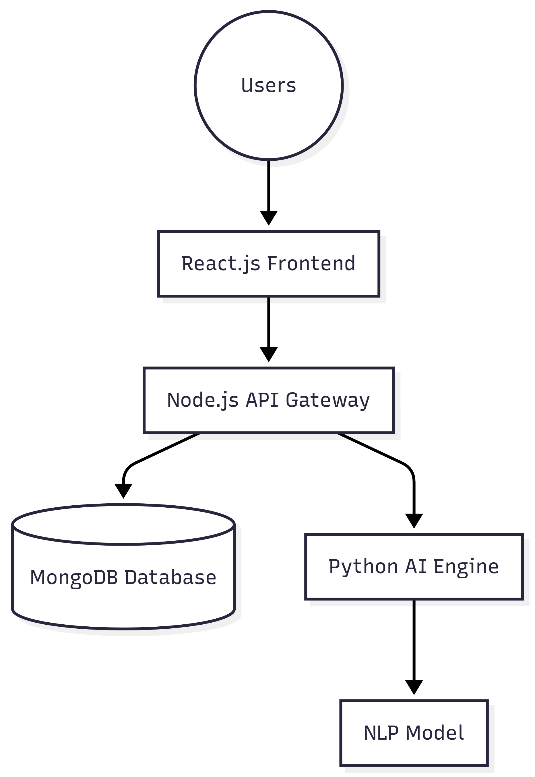
Table 2Figure 4.1: High-Level System Architecture of SAGE.

Database Design (ERD):
The database is designed to handle complex relationships between patients, doctors, and their medical history. Although MongoDB is NoSQL, we maintain a logical structure to ensure data integrity.
- Users Collection: Stores basic profile info and roles (Patient, Doctor, Admin).
- Doctors’ Collection: Contains professional details (Specialty, Fees, Clinic Location).
- Appointments Collection: Tracks bookings, timeslots, and status.
- Records Collection: Stores E-Prescriptions and uploaded medical files.
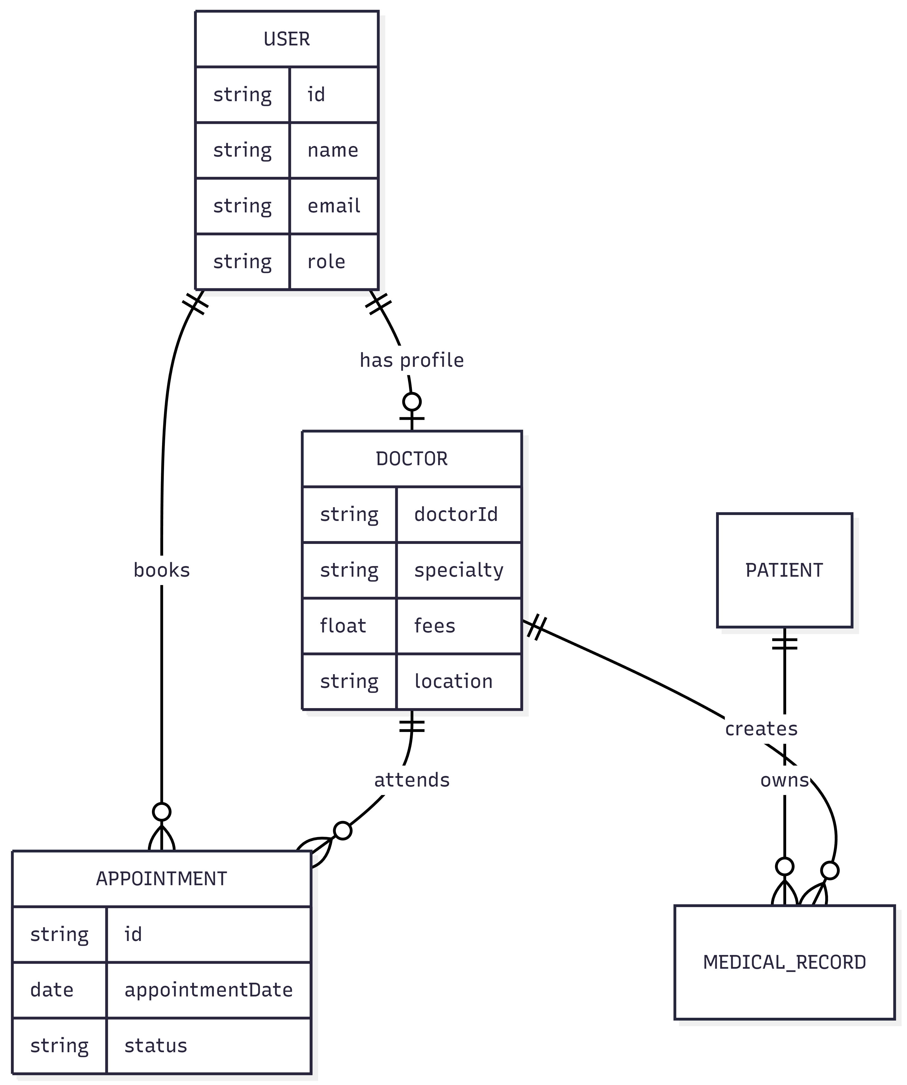
Figure 4.2: Entity Relationship Diagram (ERD) for SAGE Database.

Final Technology Stack:
Based on the project scope and objectives, the following stack has been finalized:
- Frontend: React.js (Component-based UI).
- Backend: Node.js & Express (Asynchronous request handling).
- Database: MongoDB (Scalable document storage).
- AI/NLP: Python (NLTK/Scikit-learn libraries).
- Security: JSON Web Tokens (JWT) for secure session management.

Chapter 5: UI/UX Design

Introduction:
User experience is a core pillar of SAGE. This chapter outlines the design philosophy, user flows, and the visual representation of the system's interface. The goal is to ensure that the platform is accessible to all users, including those with limited digital literacy, such as elderly patients.

Design Philosophy:
The UI of SAGE follows the "Minimalist Healthcare" approach:
- Color Palette: Clean Medical Blue (0057B7) for trust, and White for clarity.
- Typography: Sans-serif fonts for high readability.
- Accessibility: Large buttons and clear icons to guide users through the booking process.

User Flow:
The following flowchart illustrates the typical journey of a patient from symptom description to final appointment confirmation.
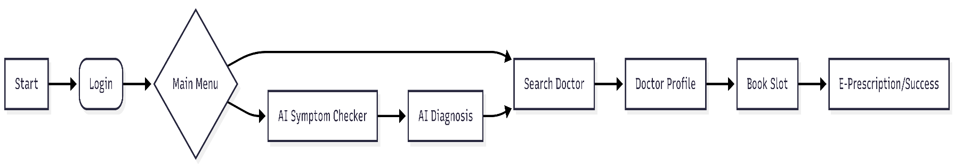
Figure 5.1: Patient Journey Flowchart.

Wireframes & Prototyping:
The system interface consists of several key modules designed to minimize user cognitive load.

Home & AI Triage
The home screen features a prominent "Ask SAGE" button, which triggers the AI Chatbot. The chatbot interface is designed to mimic popular messaging apps to ensure familiarity.

Doctor Discovery & Booking
The search results display doctors with clear indicators of their specialty, fees, and distance. The booking process is simplified into a 3-click flow: Select Date -> Select Time -> Confirm.
. 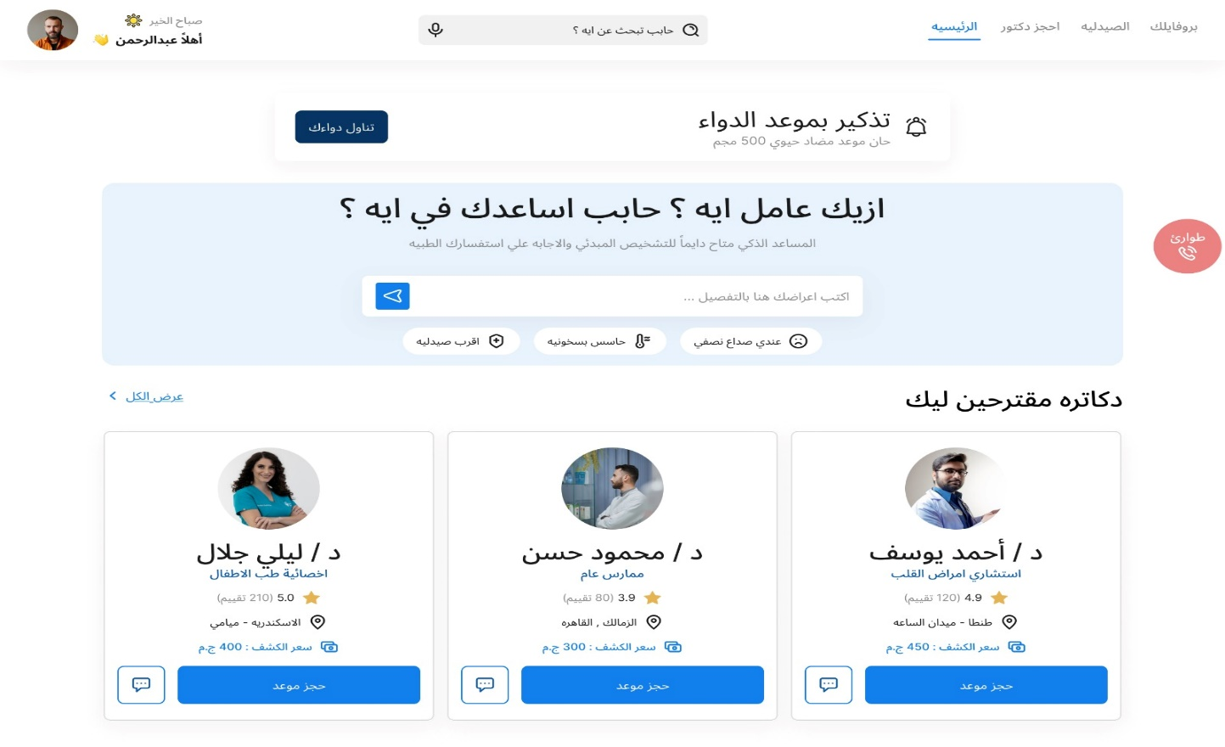

Figure 5.2: Low-fidelity Wireframes vs High-fidelity Mockups

Chapter 6: Detailed Technical Design

Introduction:
This chapter provides the lowest level of technical details for the SAGE system. It focuses on the internal structure of the software through Class Diagrams and the dynamic behavior of the system through Sequence Diagrams. Additionally, it outlines the API architecture that connects the frontend with the backend services.

Class Diagram:
The Class Diagram illustrates the object-oriented structure of the SAGE system. It defines the attributes and methods of the core entities (User, Patient, Doctor, Appointment) and the inheritance relationships between them.
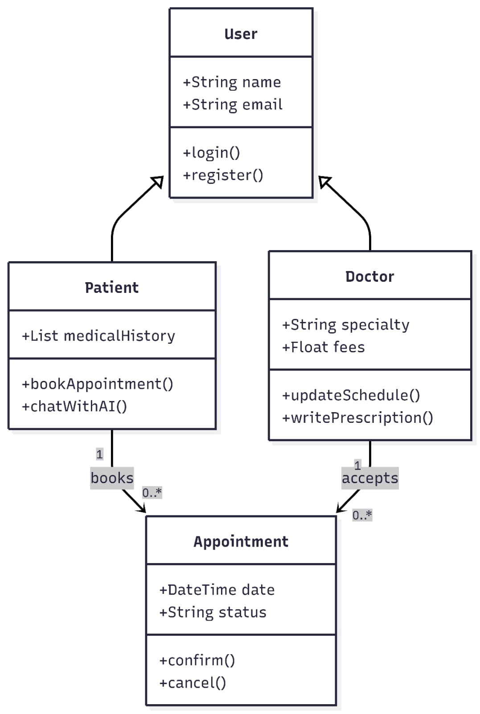
Figure 6.1: SAGE Class Diagram.

Sequence Diagrams:
To understand the interaction between different system components, sequence diagrams are used to model the most critical processes.

Appointment Booking Process
This diagram shows the communication between the Patient, the Backend Server, the Database, and the Doctor during a booking request.

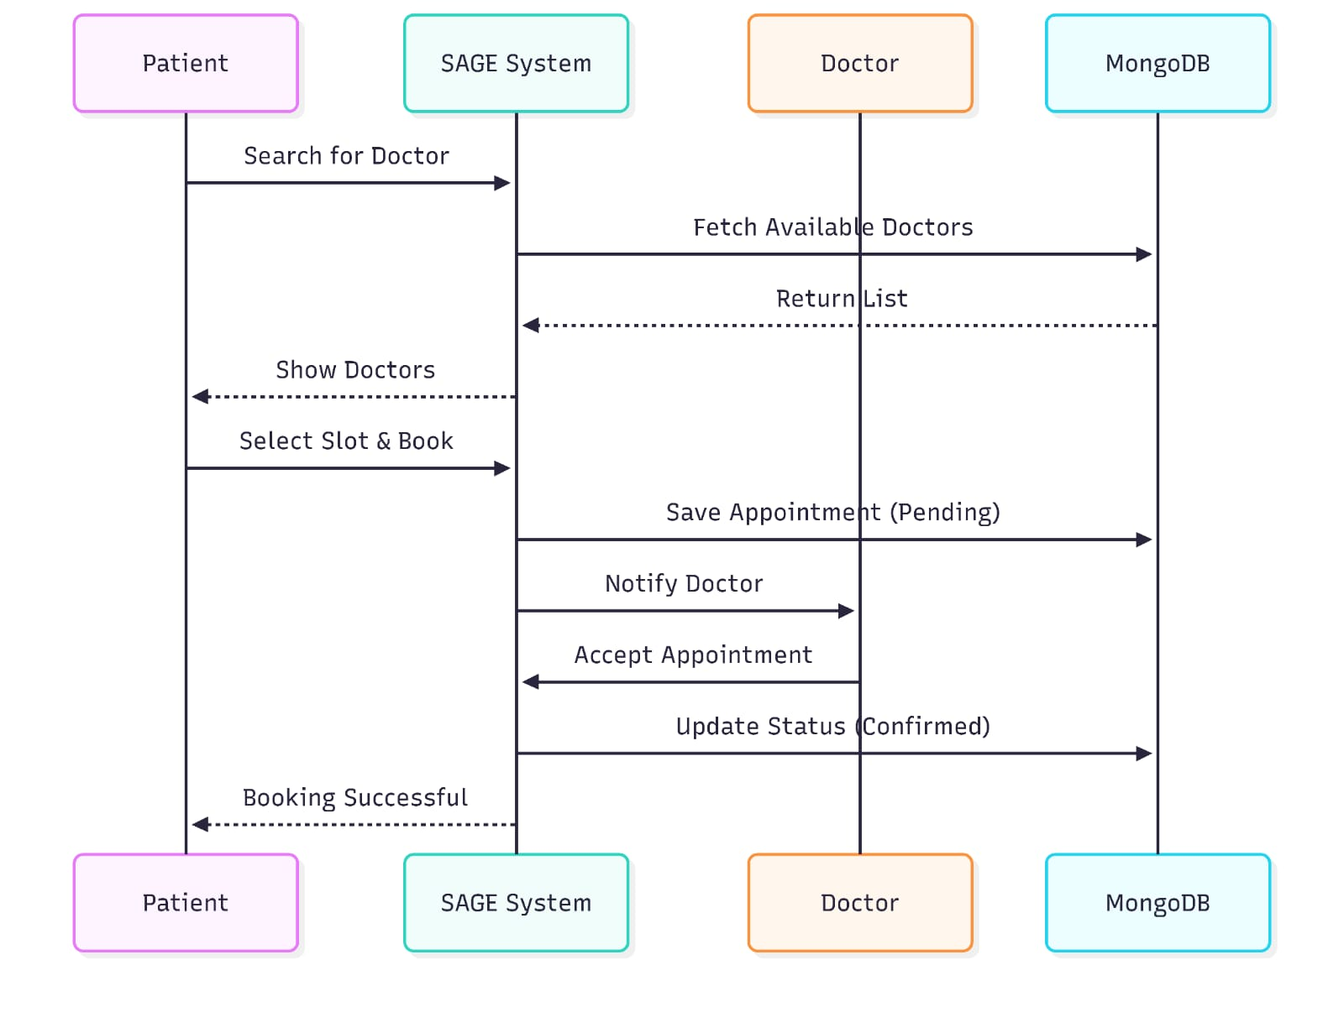
Figure 6.2: Sequence Diagram for Appointment Booking.

API Design & Endpoints:
SAGE follows RESTful API architecture. Below are the primary endpoints used for data exchange:
method | end point | descreption
post | /api/auth/signup | Register user (Patient/Doctor).
post | /api/ai/predict | Send symptoms to the AI model and receive specialty.
get | /api/doctors/search | Fetch filtered list of doctors.
post | /api/bookings | Create a new appointment record.
get | /api/patient/history | Retrieve patient’s medical records.

Database finalization:
The database schema has been finalized in MongoDB using a document-based approach. Indexes have been added to the DoctorID and AppointmentDate fields to ensure high-speed query performance during peak booking hours.

